PARTICLE SIZE DISTRIBUTION AND ACTIVE COMPOUND CONTENT OF MONIMAX® AND ANOTHER EU REGISTERED PRODUCT

Ben Dehaeck1, Maja Marien1, Monita Vereecken1, Mieke Geerinckx1, Koen De Gussem1.

1Huvepharma NV, Antwerp, Belgium

A sieving test was performed for Monimax® (nicarbazin/monensin) and another EU registered product (nicarbazin/narasin).

The composition was further compared by determination of the concentration of the active compounds in the different particle sizes. The expected concentrations for the actives of both products is 80 mg/g as indicated by the red dotted line in the graphs.

Graph 1:

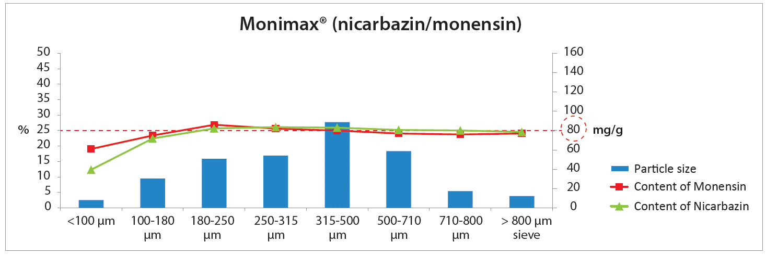

Graph 2:

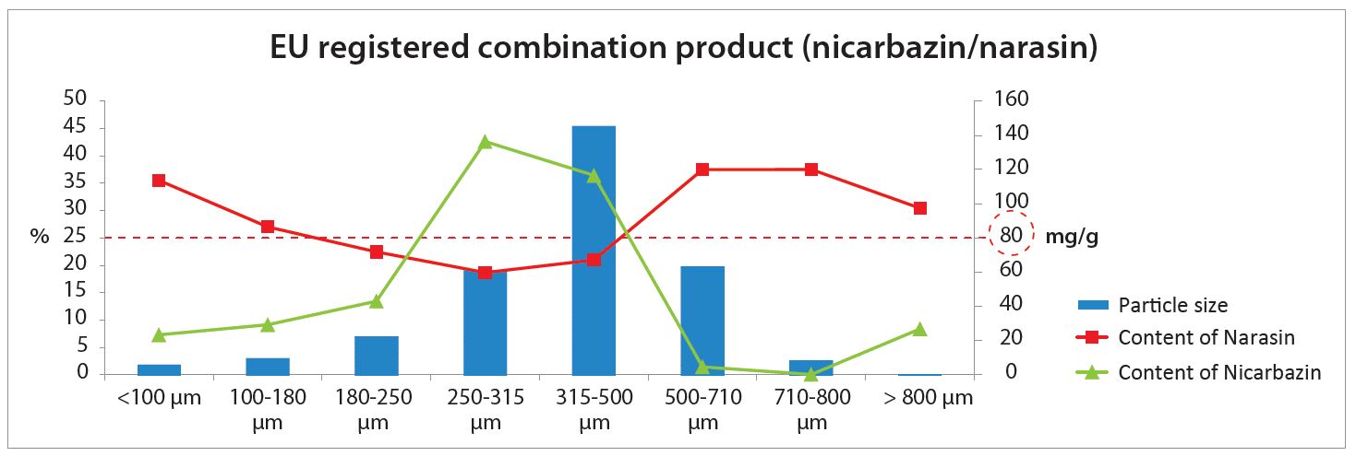

In comparison with the nicarbazin/narasin product, Monimax® (nicarbazin/monensin) shows a more optimal spread in particle size for prevention of segregation in compound feed.

Moreover, in each different particle size fraction of Monimax®, the content of monensin and of nicarbazin was within the normal range of the expected concentration of 80 mg/g (within 90-108% of expected, except fraction<100µm). This in contrast to the nicarbazin/narasin combination product where in the 250-500µm particle size range (being 44,6% of the total volume of the product), the concentration of nicarbazin was higher and the concentration of narasin was lower than the expected value. Narasin concentration was higher than expected value in the dust fraction and the fraction bigger than 500µm (23% of total).

It is clear that differences are observed in the particle size distribution and the concentration of the active in the different fractions.

Monimax® (nicarbazin/monensin), a microgranulated product is considered to be very suitable to be used in a safe and efficacious way.